**WORKSHEET 4**

**Student Name:** Vivek Kumar **UID:** 21BCS8129

**DOMAIN CAMP:** 16-01-2023 to 28-01-2023 **Section/Group:** DWWC-77

**Subject Name:** IT Skills (DSA)

# Question 1. TEMPLE LAND (ARRAY)

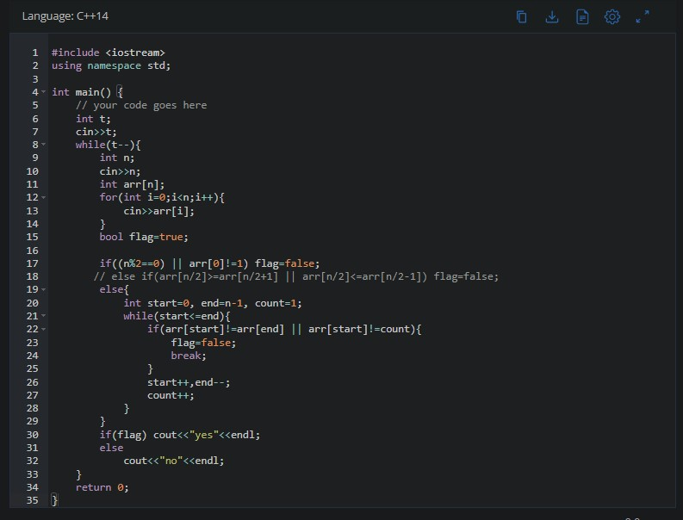

**SOLUTION:**

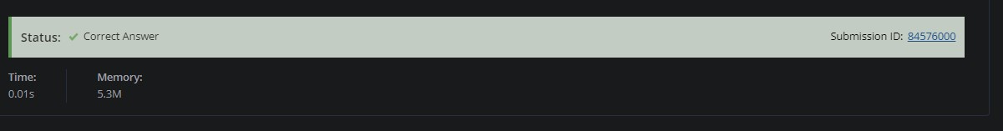

# Question 2. ROADS IN CHEFLAND (ARRAY)

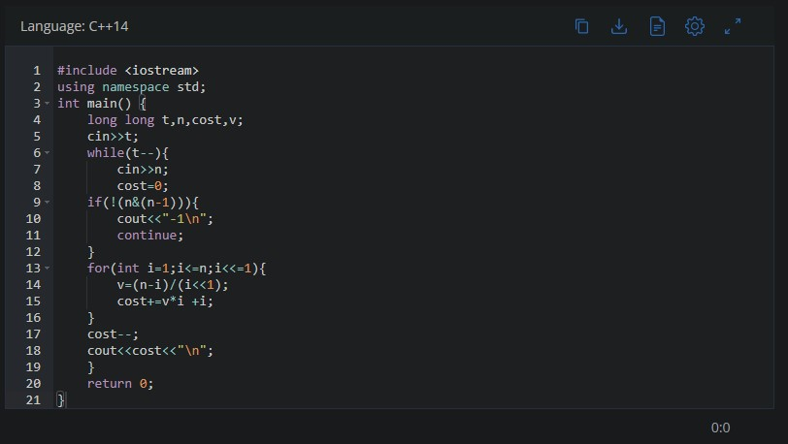

**SOLUTION:**

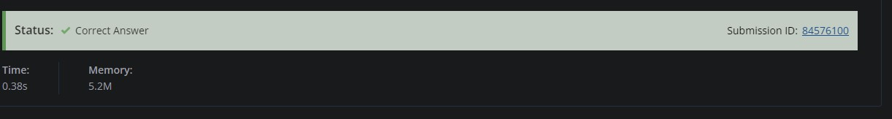

# Question 3. SOLVE THE CASE (ARRAY)

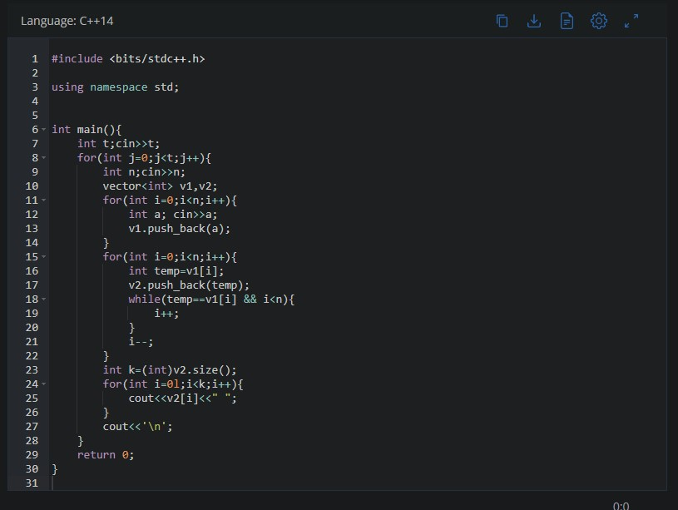

**SOLUTION:**

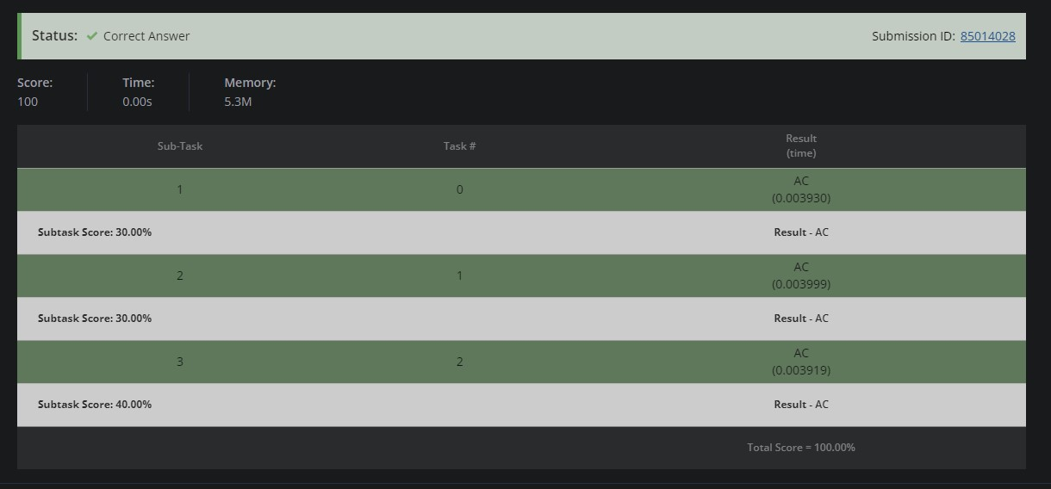

# Question 4. COOKING MACHINE (ARRAY)

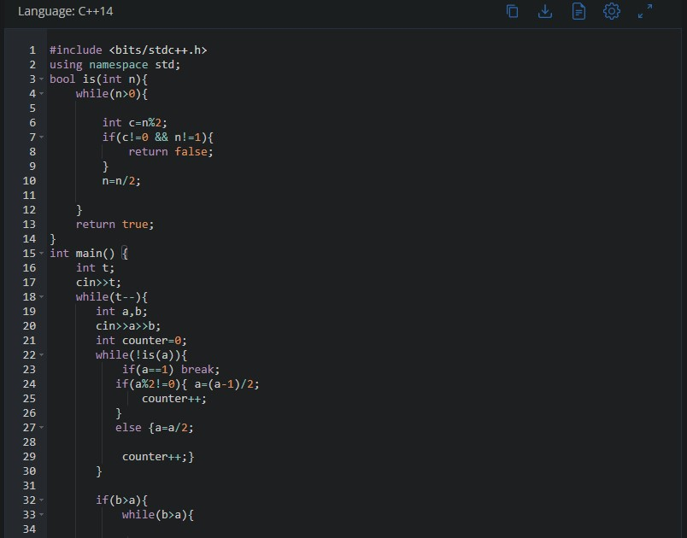

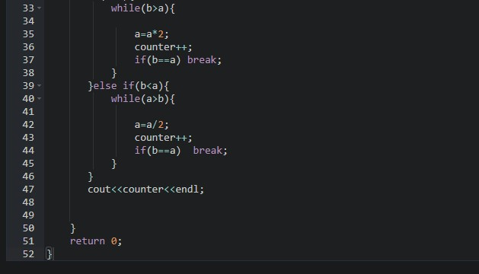

**SOLUTION:**

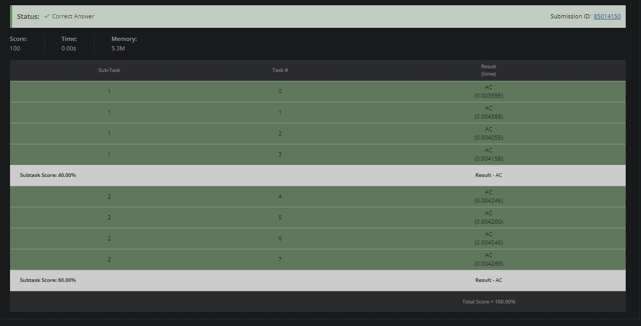

# 5 GOLD COLLECTION (ARRAY)

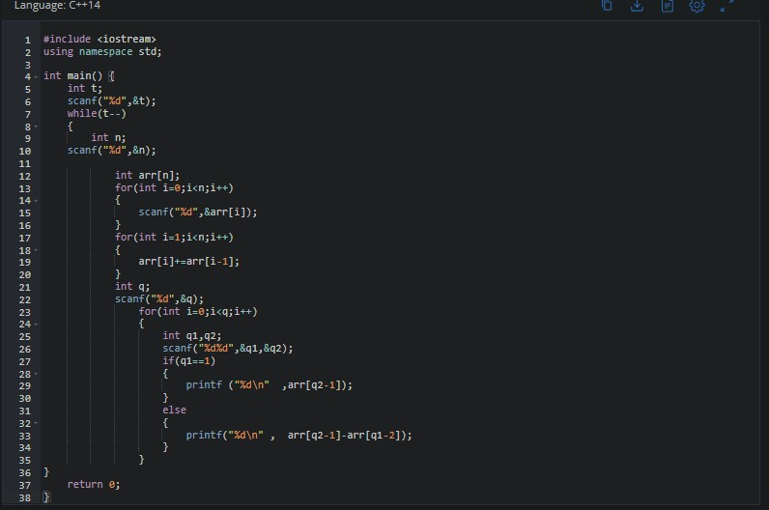

**SOLUTION:**

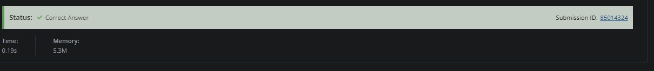

# Question 6. PALINDROME LINKED LIST (LINKED LIST)

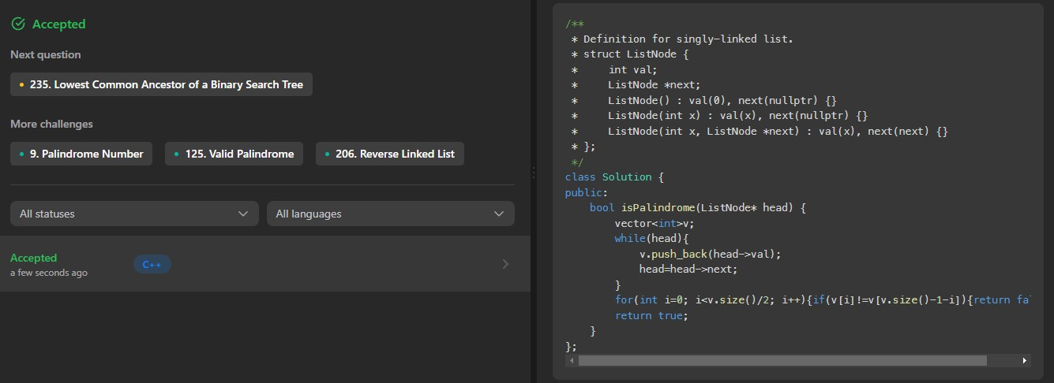

# 7 ADD TWO NUMBERS (LINKED LIST)

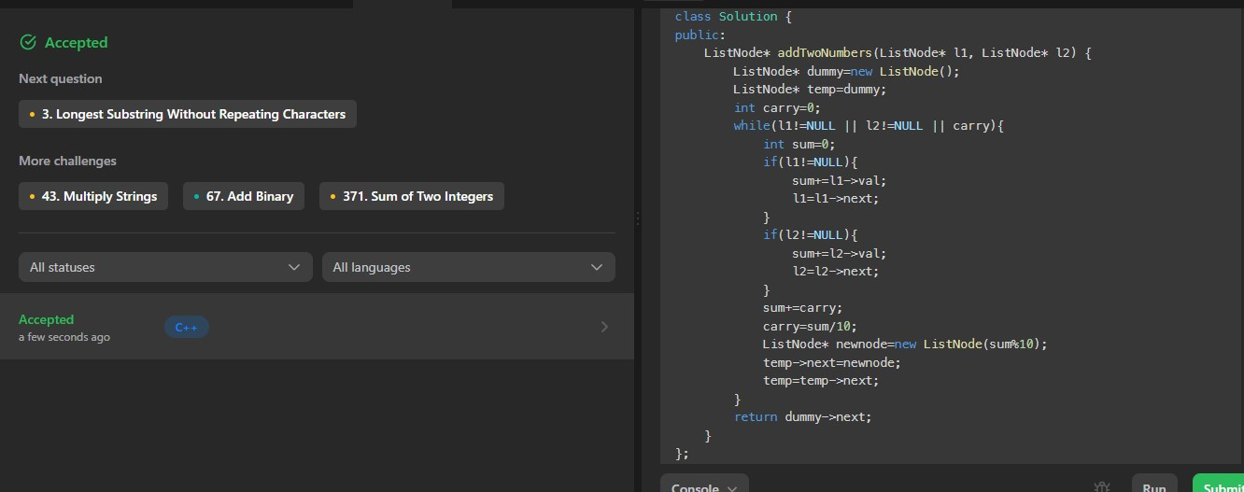

# Question 8. MIDDLE OF THE LINKED LIST (LINKED LIST)

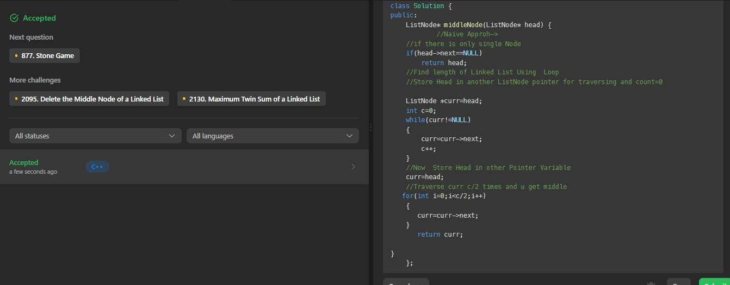

# 9 MERGE TWO SORTED LISTS (LINKED LIST)

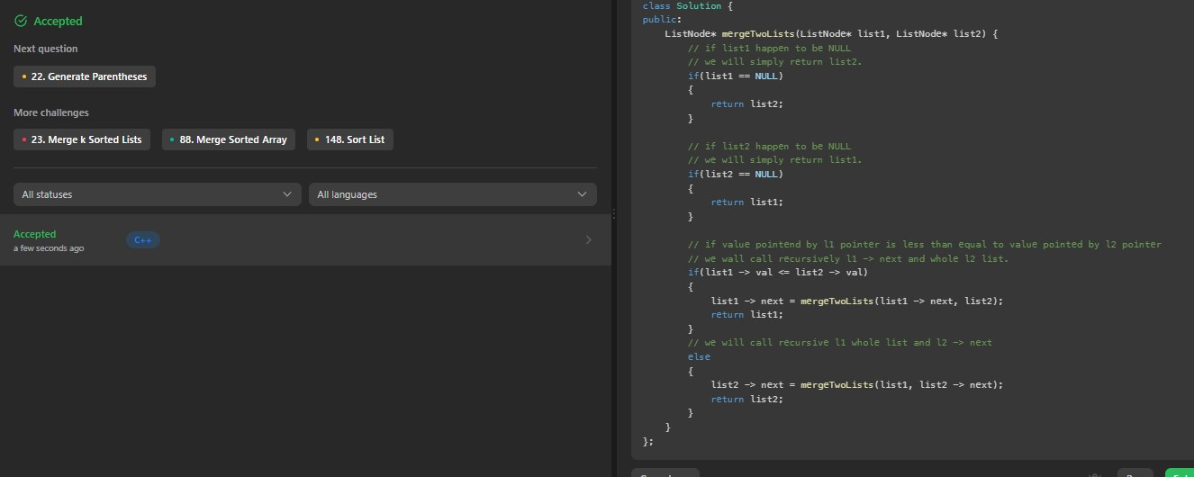

# Question 10. SPLIT LINKED LIST IN PARTS (LINKED LIST)

